EXP. NO: 10
PERFORMANCE ANALYSIS OF FM SYSTEM UNDER GAUSSIAN WHITE NOISE USING MATLAB ;
PROGRAM:
clc; clear; close all;
fs = 100000;
t = 0:1/fs:0.02;
fm = 500; fc = 5000; kf = 100;
m = cos(2*pi*fm*t);
c = cos(2*pi*fc*t);
fm_sig = cos(2*pi*fc*t + 2*pi*kf*cumsum(m)/fs);
noisy = awgn(fm_sig,10,'measured');
figure;
subplot(4,1,1); plot(t,m); title('Message Signal'); grid on;
subplot(4,1,2); plot(t,c); title('Carrier Signal'); grid on;
subplot(4,1,3); plot(t,fm_sig); title('FM Signal'); grid on;
subplot(4,1,4); plot(t,noisy); title('FM with Noise'); grid on;
WAVEFORM

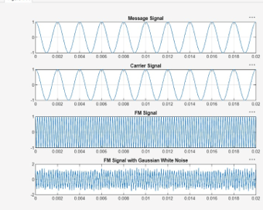

OUTPUT:

